This project which contains 2 files named Covid Deaths and Covid Vaccinations, which are both loaded on SSMS . Data types of relevant field were changed to integer to avoid later conversion during code execution.

The aim of this Project is to analyse the dataset related to deaths and vaccinations due to Covid-19.

Initially, Total deaths were analysed grouped by Location.

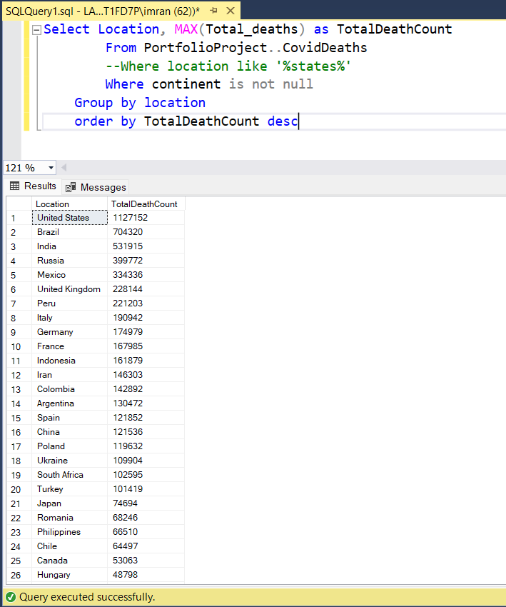

Then total deaths were analysed by continents using the syntax below.

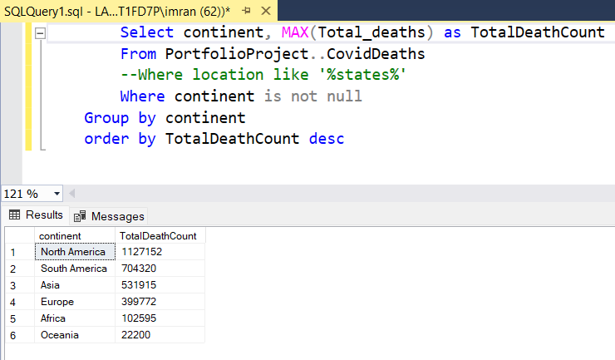

Next the global deaths percentage was queried

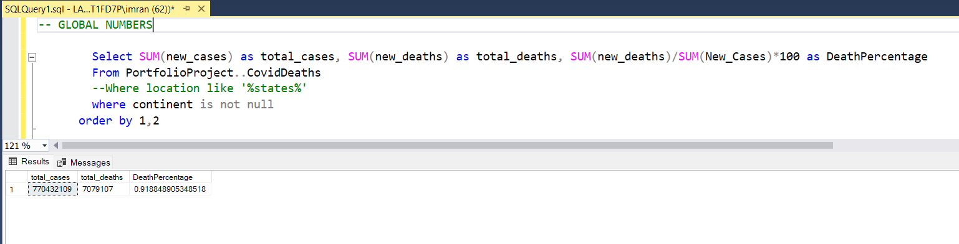

Using the Syntax below, Percentage of population was analysed who received atleast one Covid Vaccination and this was accomplished by joining two tables covid deaths and covid vaccinations

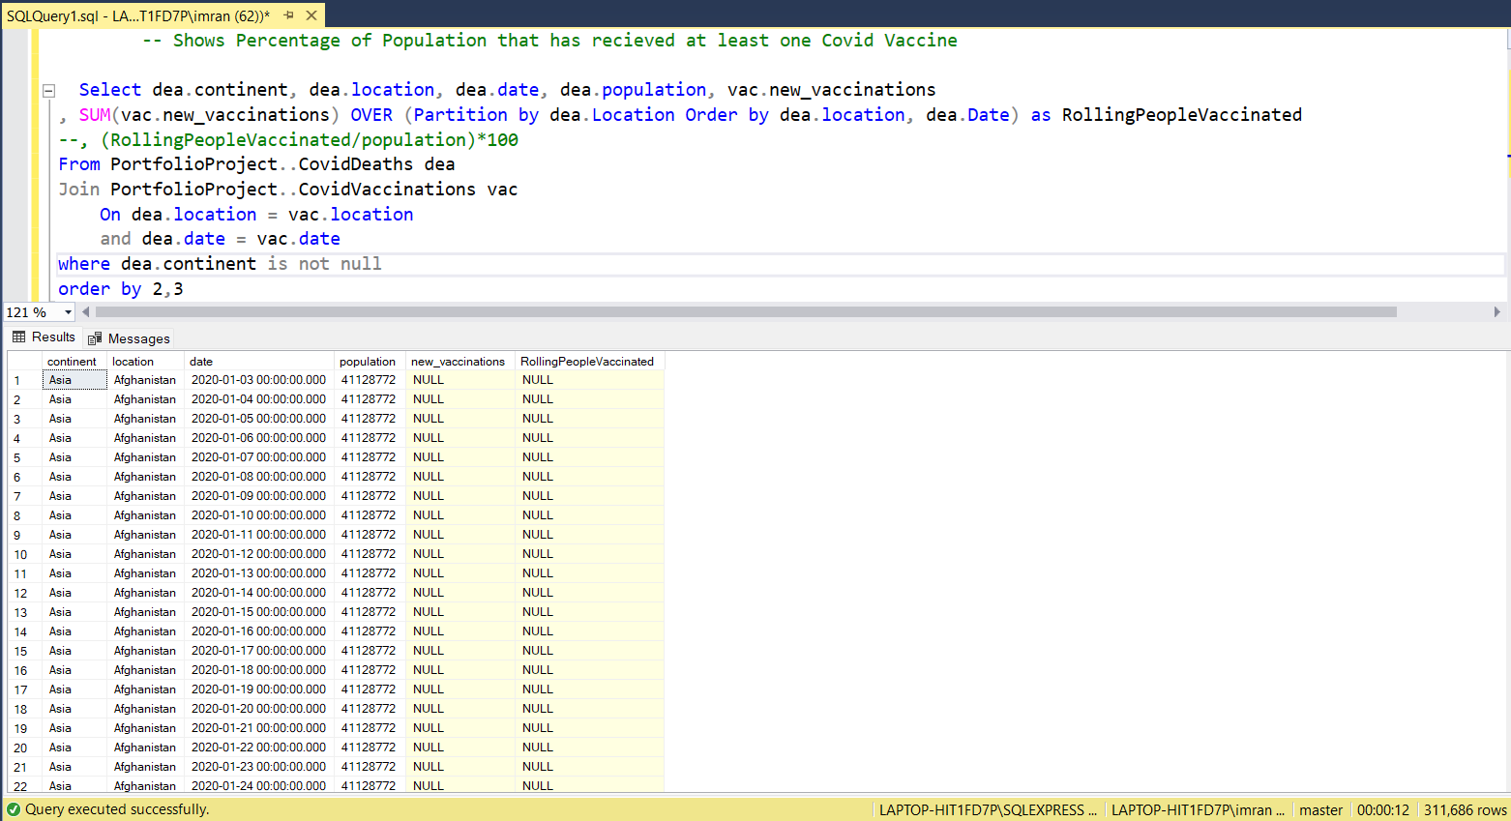

Furthermore, analysing the mortality rate using new deaths vs population was carried out using CTE

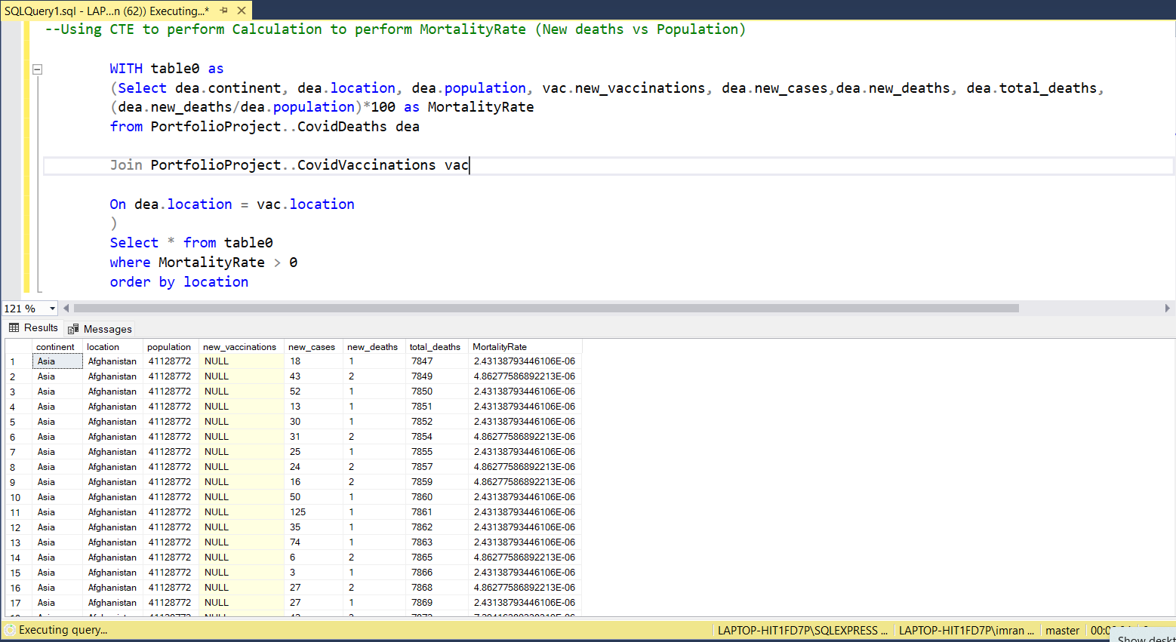

Temp table was created

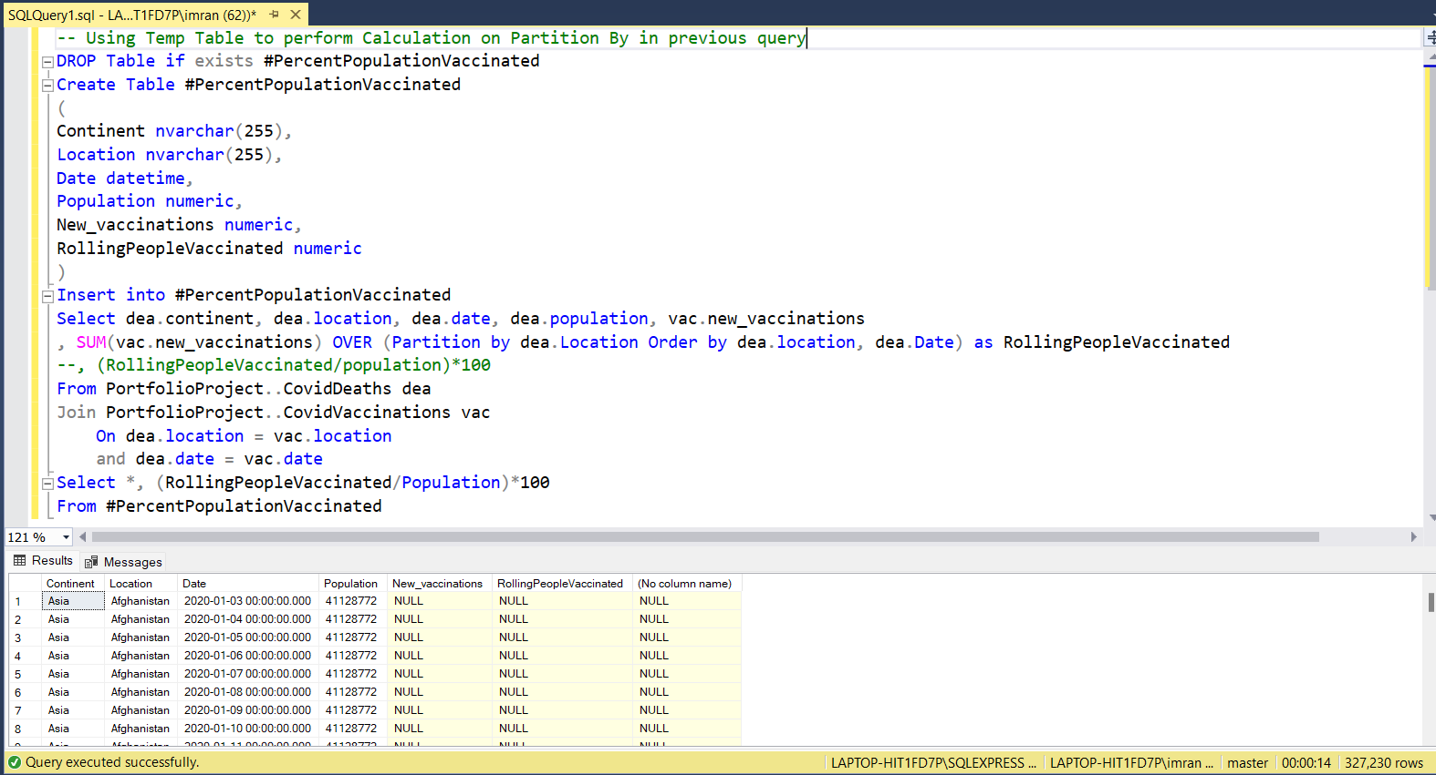

Finally to store the data for later visualisation, Create view was created

